# Chapter 5: System Implementation and Testing

## 5.1 Introduction

This chapter talks about the various hardware and software requirements for the system to work properly. It gives the minimum requirements and the recommended requirements for the system to work perfectly that is for the hardware requirements and for the software requirements it gives the required software and gives justification why that software is required. It also gives a brief description of about the dataset and how it was trained into the prediction model to get the desired output. The testing paradigms also included that is the black box testing where a table of information was generated to display the specific tests that were carried out and the results of the test cases with sufficient evidence.

## 5.2 Description of the Implementation Environment

### 5.2.1 Hardware Requirements

The table below show the hardware requirements for the system to work properly and also suggests the recommended requirements for the system to work perfectly (Hazelwood et al., 2018).

Table 5: Hardware Requirements

|  |  |  |
| --- | --- | --- |
| **Component** | **Minimum** | **Recommended** |
| Processor | 1.9 gigahertz (GHz) x86- or x64-bit dual core processor | 2.8 gigahertz (GHz) x86 |
| Storage | 256 GB SSD or 512 HDD | 512 GB SSD or 1TB HDD |
| RAM | 8 GB (7.88 GB useable) | 16.0 GB (15.9 GB usable) |
| System Type | 64-bit operating system, x64-based processor | 64-bit operating system, x64-based processor |

### 5.2.2 Software Requirements

Hardware only is never enough to run a project there is always need of software and below are the software requirements for the system that will ensure smooth running (Amershi et al., 2019).

Table 6: Software Requirements

|  |  |  |
| --- | --- | --- |
| **Component** | **Description** | **Justification** |
| Operating System | Any Windows 7 or above and any Mac OS 10.8 or newer | A device with any of the specified operating system makes it easier to access the system securely and running the system on a stable operating system |
| Internet or Broadband Network compatibility and connection | 5 Mbps or better | Most of the systems are developed and run on the internet and this makes it easier to share code and also to save the code and for this internet connection is required to connect to the internet connection |
| Web Browser | Google Chrome or Microsoft Edge | Web browsers are the platforms that allow accessing most of the developed systems. The aim to have a web browser compatible device is to allow sharing the system with many people who can then access and use the system. |

## 5.3 Description of the dataset

The player performance prediction model has two datasets that is working on that is the batting dataset and the bowling dataset.

### 5.3.1 Batting data

This is data that is downloaded from the scoring system from the leaderboards report, specifically the batting leaderboards report. This is report that is generated from the scores that is updated after every match and it stores all the batting data of all the players. The batting data was downloaded in csv format and loaded into the prediction model where the data is then cleaned and pre-processed such that any row that has null values is removed so that the final data will only predict the performance of all the players that have all the data. The dataset is then split into training and testing data using the ratio 0.8:0.2 where 0.8 is the training data and 0.2 is the test data. So once the dataset was split it then the dataset with 0 missing values is trained and then it uses 6 features to do the prediction that is the previous five performances for the batsman and the average of the batsman. So, it is such that if the performance for the next match is high and the average of the player is high then it selects that player in the dataset. This means that the prediction of the next match that is the runs and the average have a direct relationship where if both are high then that player is selected. Top six players who are predicted to perform well in the batting data are selected and starting eleven of the next match. This dataset had a few null values and thus there was need to clean the dataset before actually training and testing the data.

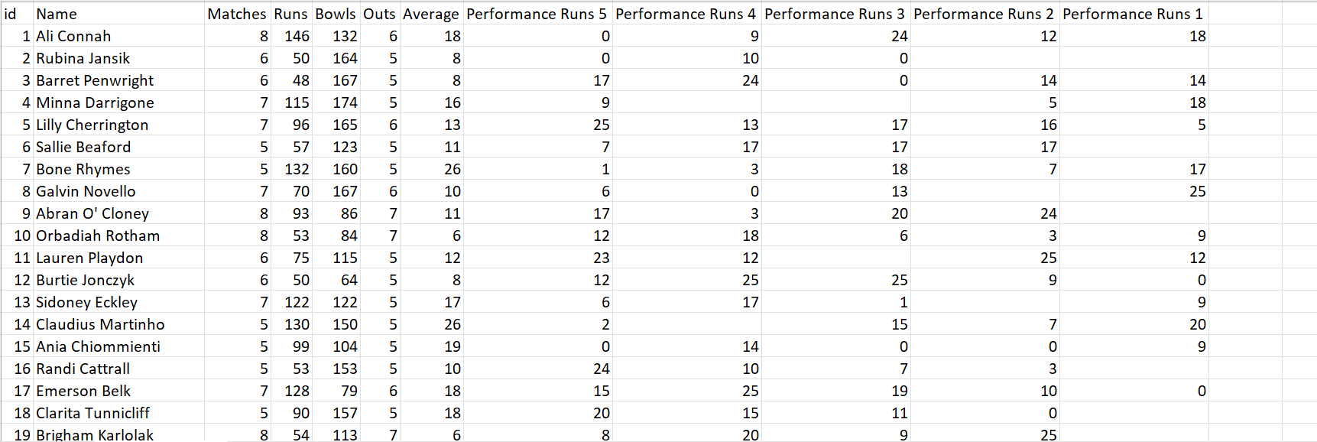

Figure 5. 1: Batting Dataset Overview

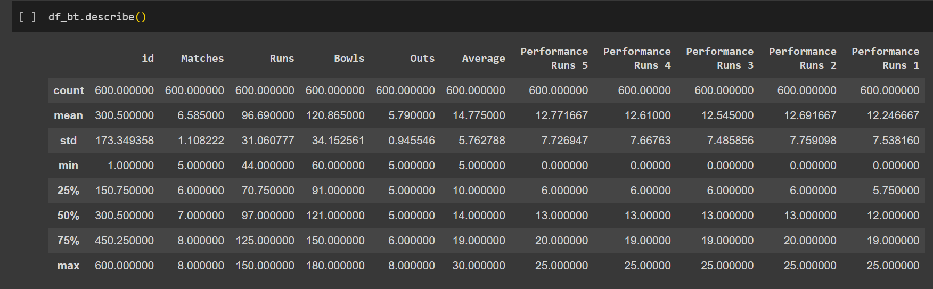

Figure 5. 2: Batting Data Description

### 5.3.2 Bowling data

This data was also downloaded from the scoring model where just like the batting data it the bowling data was also updated after every match. The bowling data was downloaded in csv format then loaded into the prediction model where the data was then cleaned and pre processed since there was presence of null values in some of the players data so the final data that was used to predict the performance had all the rows will the null values removed thus only players with full performance data was used to predict the performance. The dataset was then split into two that is the training data and the testing data using the ration 0.8:0.2 where 0.8 was the training data and 0.2 was the testing data. Just like the batting data the bowling data also used 6 parameters to predict the performance, that is performance 5, performance 4, performance 3, performance 2, performance 1 and the economy. So, the previous 5 performance data was used to predict the performance of the players together with the economy such that the economy and the performance prediction has an inverse relationship where the higher the performance and the lower the economy this enabled a player to be selected in the starting eleven. So, 5 players from the bowling data were selected and added to the 6 players that were predicted from the batting dataset and this returned a list of eleven players that were predicted to perform well for the upcoming matches.

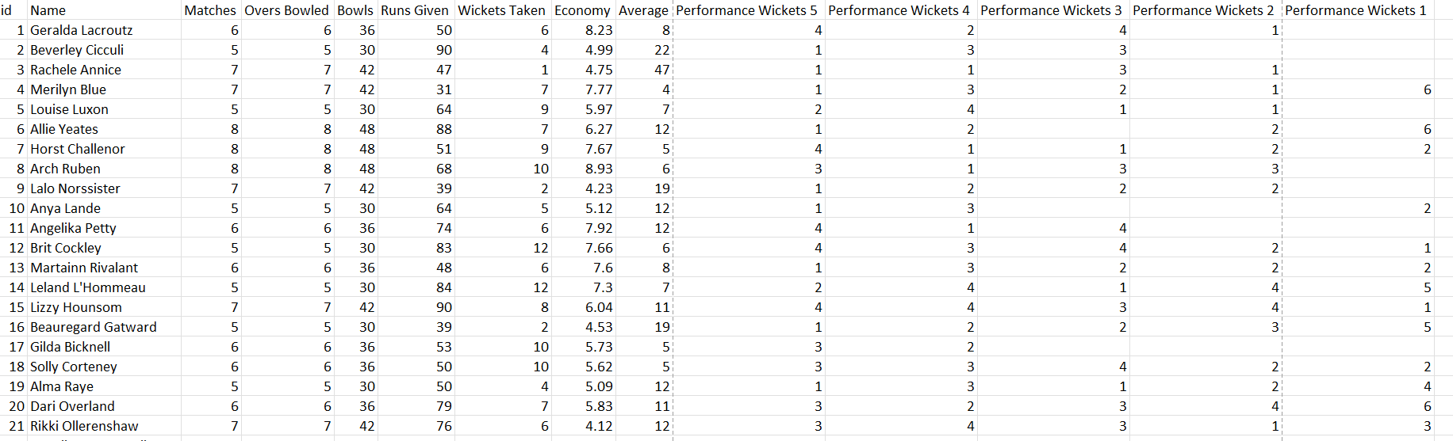

Figure 5. 3: Bowling Data Overview

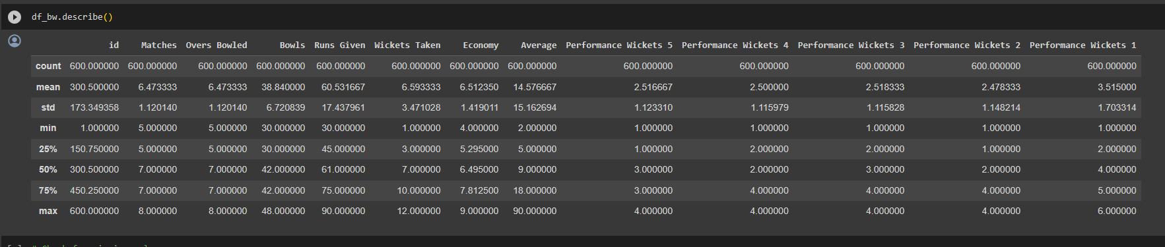

Figure 5. 4: Bowling Data Description

## 5.4 Data Training

As mentioned above the data was obtained from the web application where the two datasets are downloaded that is in csv format. Once downloaded there are two models that is the batting prediction model and the bowling prediction model so since there are two datasets the batting model will now predict the top six players suitable for the next match and the bowling model will predict the top 5 players for the next match and then these players will then be selected in the starting eleven of the next match. So, the process started when the data was downloaded and fed into the system where the data first was cleaned and pre processed such that any data with null values was removed so that the data that is trained is consistent so that the accuracy returned is the highest possible.

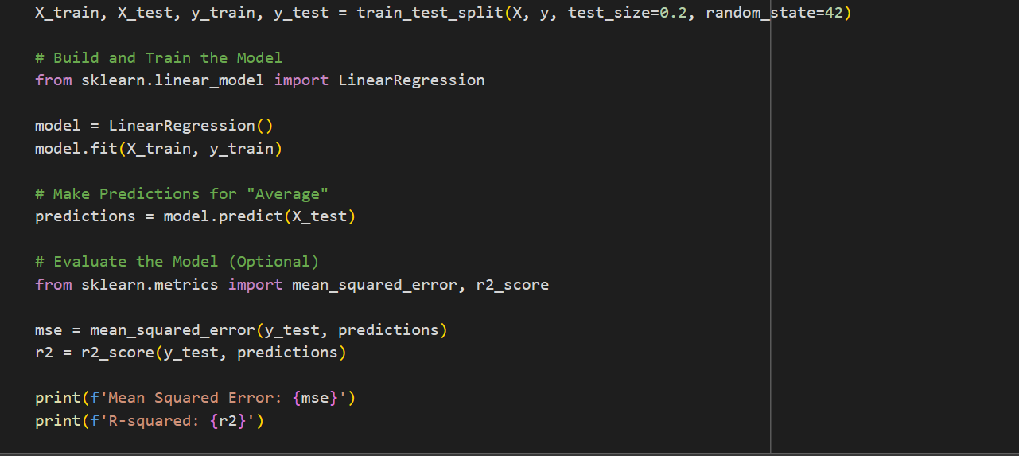

Figure 5. 5: Data Splitting and Training

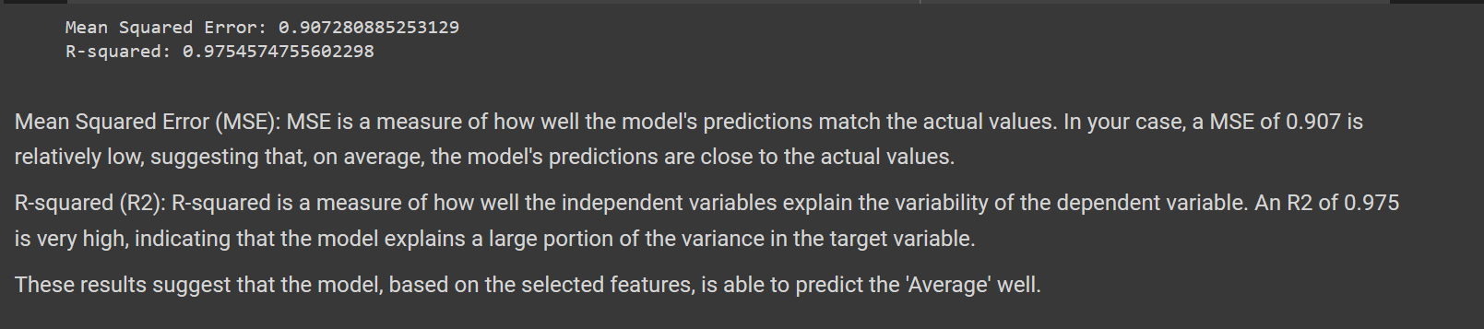

Figure 5. 6 :Outcome of the Data Training

## 5.5 Testing

Testing is process of checking the system whether it is working as expected and to identify and solve any errors in the system before handing it over. This enables to solve the identified errors beforehand so that the system works as expected.

### 5.5.1 Black Box testing

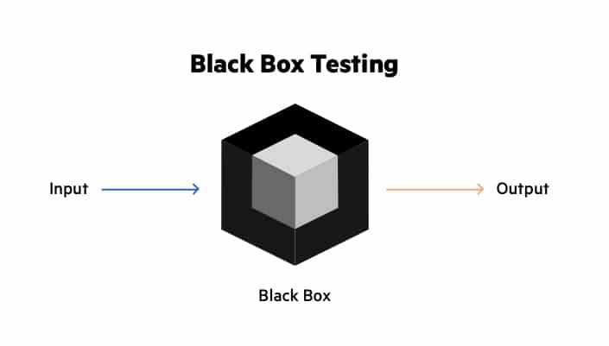Black box testing was used to check if the data input was correct and verified it and validated it against the database. This type of testing mostly allows the tester to know the top surface of what is happening and nothing deep that is it allows the tester to check if the system is outputting or doing whatever is expected after giving the correct data input. So, basically while carrying out black box testing the tester does not how the system is coded, they only focus on what output the system is returning when a data input is done. This black box testing paradigm was mainly used to confirm what happens when the tester inputs certain values for data when checking if the system will act accordingly or not(Romdhana et al., 2022).

Figure 5. 7: Black Box Testing (Romdhana et al., 2022)

### 5.5.2 Testing results

The following tests were carried out and the results and verdicts were as shown below.

Table 7: Test Case and Results

|  |  |  |  |  |  |
| --- | --- | --- | --- | --- | --- |
| Test ID | Details | Test Data | Outcome | Verdict | Evidence |
| 001 | Trying to access the login system with an empty field. This should block the user entry into the system unit the correct data is entered and no fields are blank | Username: [admin@admin.com](mailto:admin@admin.com)  Password: left blank | Error message displayed stating password field is required | Pass | Appendix 3 |
| 002 | Trying to access the system by logging in with incorrect password. This should not allow access into the system until the correct credentials are entered. | Username: [admin@admin.com](mailto:admin@admin.com)  Password: p’ssword  Correct Password: password | Error message displayed stating incorrect password | Pass | Appendix 4 |
| 003 | Registering a new club with an email that does not have the @ symbol. This should not allow to add or create a new club. | Club Name: Premier  Email: 123 Ground: Jamhuri | An error message displayed suggesting to enter the symbol ‘@’ in the email address | Pass | Appendix 5 |
| 004 | Moving on to another form for data entry with some values not entered. This should not allow to access the other forms without one field being empty. | Moving to bowling first form from batting first form with a runs left empty for one of the players | An error message being displayed asking the tester to fill in the form where the required fields are not left empty before moving to the next form. | Pass | Appendix 6 |
| 005 | Trying to fill in the batting form for the players that been selected did not bat. This should block out input for data entry if did not bat is selected. | Did Not Bat selected for a player. | It did not allow data entry until the selection was changed from Did Not Bat to Batted. | Pass | Appendix 7 |

## Appendix 3

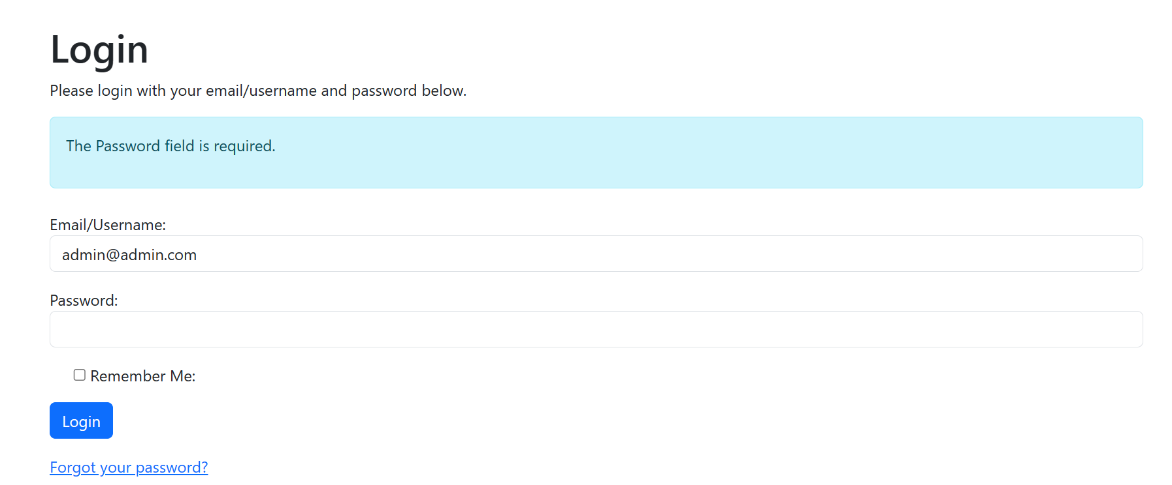

## Appendix 4

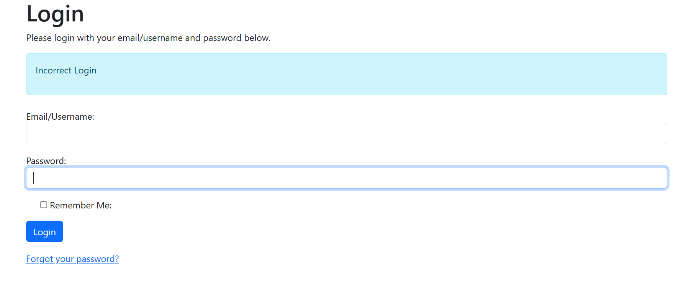

## Appendix 5

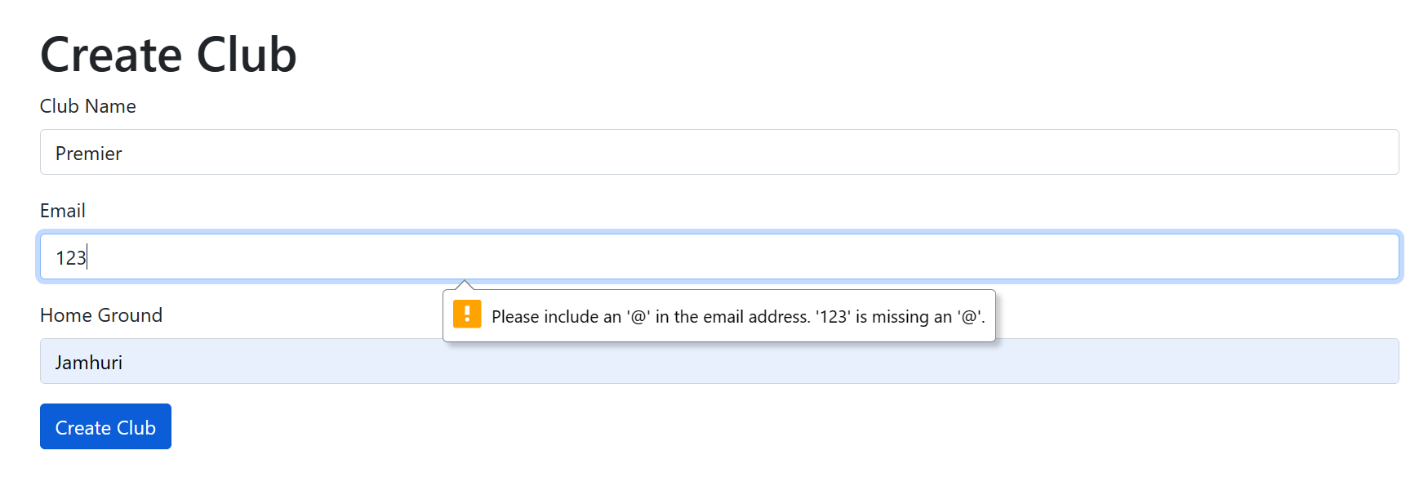

## Appendix 6

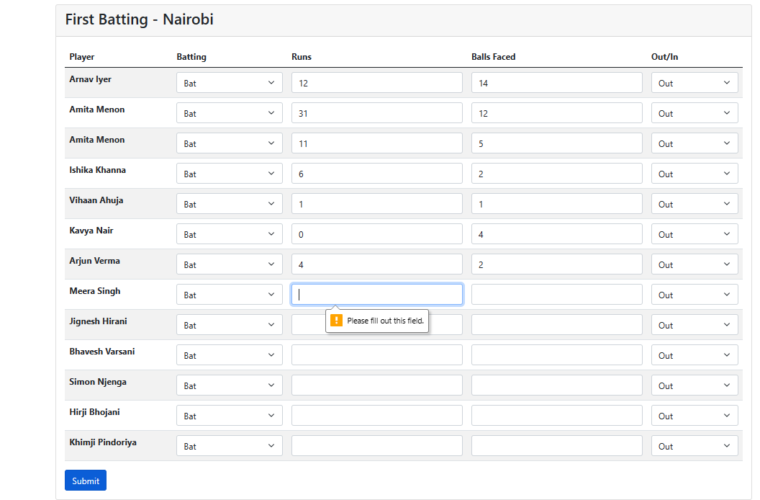

## Appendix 7

